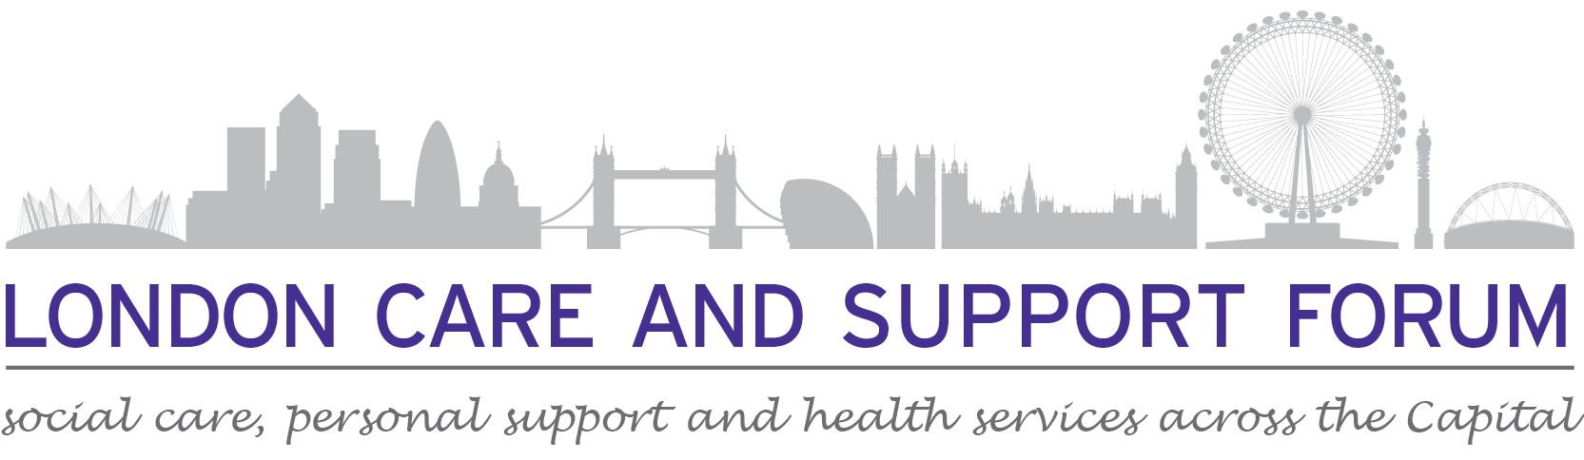
International Recruitment for Social Care

“Unlocking Sponsorship Licences: Costs, Complexities, and Compliance”
08/12/2023 2.00 – 3.30pm

LCAS are facilitating a series of virtual meetings and live events to provide advice and signposts to further support for providers who are interested or involved with International Recruitment.

You will hear from parties involved from the Home Office to CQC, legal advisors and other experts.

We will covering various topics such as modern-day slavery, compliance, funding, accommodation and the importance of pastoral care (plus more).

These events are for organisations based in, or working in the boroughs covered by NC London, SE London and SW London.

You will be able to ask questions on the day or in advance. If would prefer to submit these anonymously in advance of the meeting, please do, using the contact details below.

To join this event, please use this link
https://forms.gle/GPx7VVYBEJ91ZwNLA

Any queries,
Contact Peter Webb peter@lcasforum.org 07956878901 Or
Dudley Sawyerr dudley@lcasforum.org 07984466130 E&OE
E&OE.

